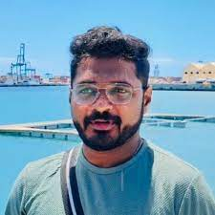

Dr. Muhammad Ameen, National University, Singapore

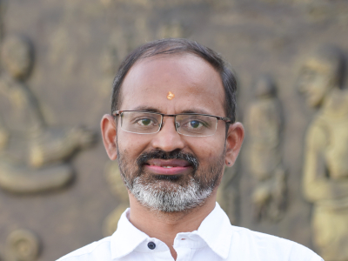

Dr. M. Sabarimalai Manikandan, Associate Professor, IIT Palakkad, India

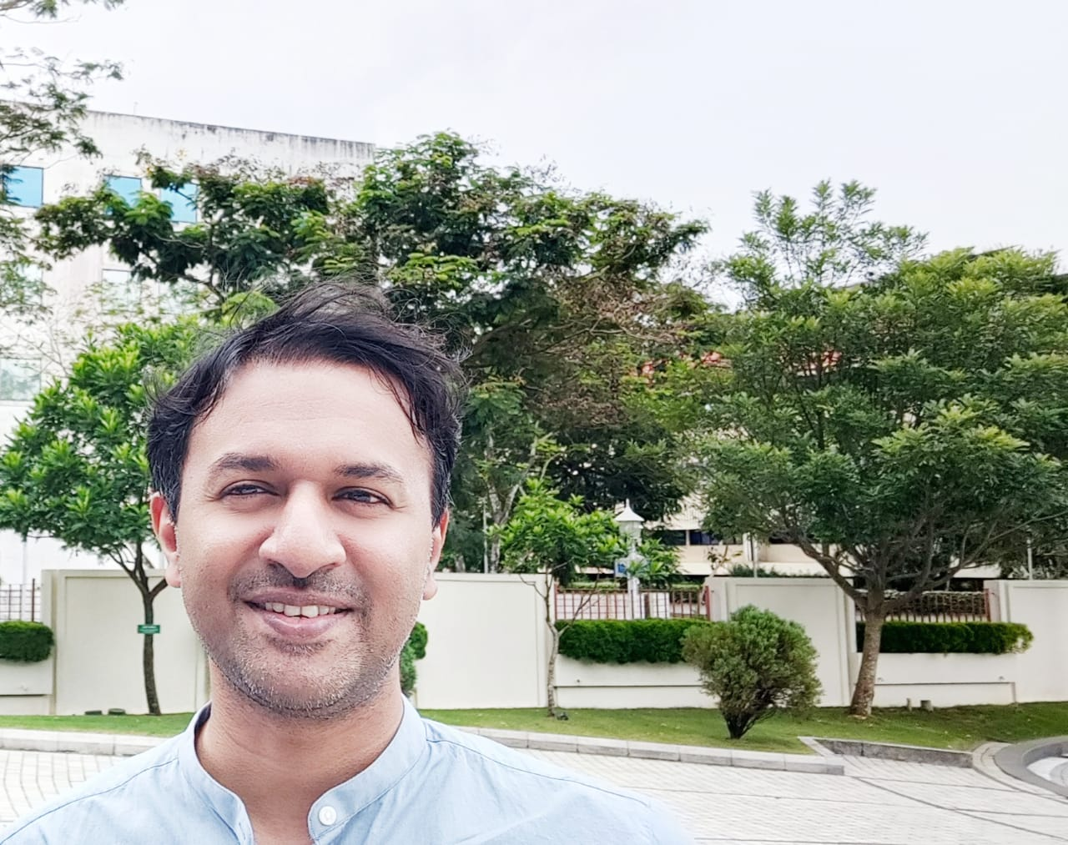

Dr. Anishin Raj M.M, Muthoot Institute of Science and Technology, India

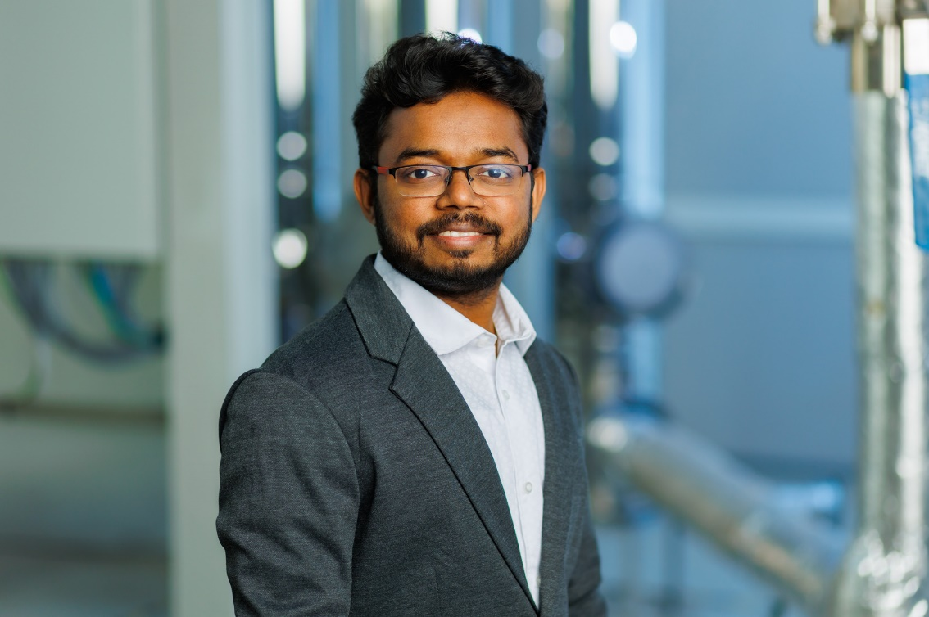

Dr. Sreenath Sukumaran,Tallinn University of Technology ,Estonia.